**Name**___________________________ **Date**__________________

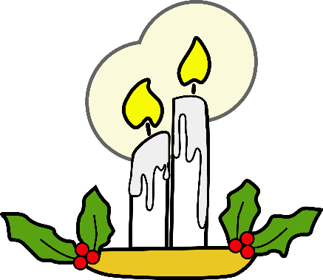

**Charles Dickens Webquest**

**Introduction:** Charles Dickens is said to be one of the greatest writers that has ever lived. Before we read one of his novels, I would like you to spend some time getting to know this man and learning what the world was like during the Victorian period.

**Instructions:**

* You may work with a partner or on your own. Only groups of two.
* For numbers 1-2, the OLDEST partner will search the web while the other partner writes the answers down. However, you should both read and answer the questions together.
* For numbers 3-6, the YOUNGER partner will search the web while the other partner writes the answers down.
* When are finished, you will create a timeline, a comic strip, or an acrostic poem giving information about Charles Dickens.

1. **Charles Dickens Timeline-**

[www.charlesdickensinfo.com/life/timeline/](http://www.pbs.org/wgbh/masterpiece/olivertwist/dickens_timeline_text.html)

1. What was the date of Charles Dickens’ birth?
2. What happened to him in 1848?
3. What was Dickens doing right before he died?
4. What famous story did Dickens write in 1843?
5. Dickens married Catherine Thompson Hogarth in 1836. How many children did they have?
6. What happens between Catherine and Charles in 1858? Why?
7. Edgar Allan Poe died in 1849. What is going on in Dickens’ life at that time?
8. **Map of London-**

<http://charlesdickenspage.com/dickens_london_map.html>

1. Locate and click on **Camden Town**. Which family from A Christmas Carol lived in Camden Town?
2. Locate and click on **Bedlam**. What is Bedlam?
3. Locate the area **The City**. What reference is made to The City in A Christmas Carol?
4. Locate **Cornhill**. What reference is made to Cornhill in A Christmas Carol?
5. **Victorian Era-**

https://[www.Biography.com/news/charles-dickens-facts](http://www.Biography.com/news/charles-dickens-facts)

1. List the 5 “Gruesome Facts”
2. Choose two and write a three sentence reaction to each fact.
3. **Workhouses-**

<http://www.victorianweb.org/history/poorlaw/dietwh.html>

Workhouses were built to house poor Victorians, who worked for a small amount of food and money. Name five foods that poor Victorians were given here.

1. **School-**

<http://www.logicmgmt.com/1876/schoolday.htm>

Please read the list of 10 rules, which were found in a typical Victorian classroom. In your opinion, which rules should still be used in schools today? Explain why. 1 paragraph

1. **Reading Dickens-**

<http://charlesdickenspage.com/reading_dickens.html>

1. In the nineteenth century, who read Dickens?
2. Why, as we read Dickens today, is it challenging?